.



# 11-EXCEPTIONHANDLING

**Department of Computer ScienceandEngineering**|**Rajalakshmi EngineeringCollege**

181

**Ex.No. : 11.1 Date:02.06.24**



**RegisterNo.:230701381 Name:VIJAYATHA.L**

# EXCEPTIONHANDLING

To find whether a digit lies in the specified range(1-100). Handling exceptions forinvalid inputs and out-of-range numbers .

InputFormat:

Userinputsanumber. Output Format:

Confirmtheinputorprintanerrormessageifit'sinvalidoroutofrange.

**Forexample:**



|  |  |
| --- | --- |
| **Input** | **Result** |
| 1 | Validinput. |
| 101 | Error:Numberoutofallowedrange |
| rec | Error:invalidliteralforint() |

**Program:**

try:

a=input()

if(int(a)>0andint(a)<101): print("Valid input.")

else:

print("Error:Numberoutofallowedrange") except:

print("Error:invalidliteralforint()")

.

**Department of Computer ScienceandEngineering**|**Rajalakshmi EngineeringCollege**

182

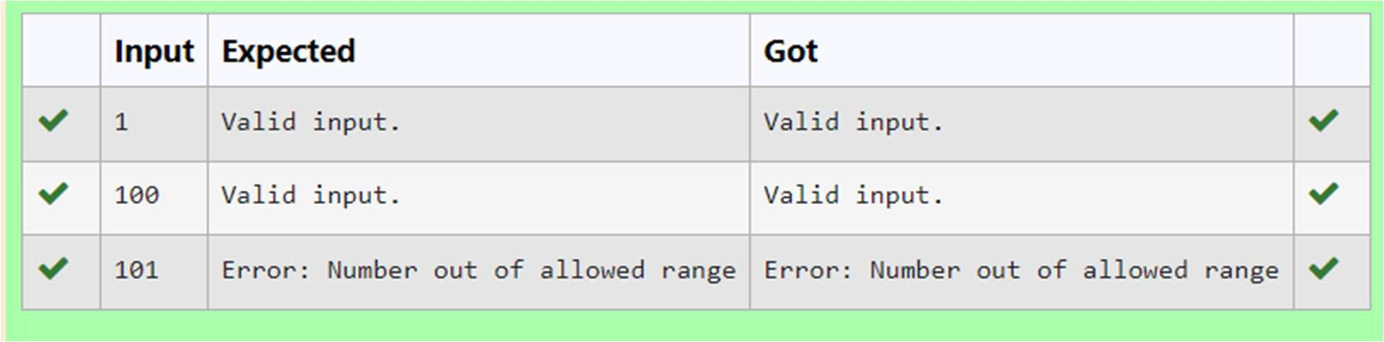

.



**Department of Computer ScienceandEngineering**|**Rajalakshmi EngineeringCollege**

183

**Ex.No. : 11.2 Date:02.06.24**

.



**RegisterNo.:230701381 NameVIJAYATHA.L**

# EXCEPTIONHANDLING

Write a Python program that performs division and modulo operations on two numbers providedbytheuser. Handledivisionbyzeroandnon-numericinputs.

InputFormat:

Twolinesofinput,eachcontaininganumber. Output Format:

Printtheresultofdivisionandmodulooperation,oranerrormessageifan exception occurs.

**Forexample:**



|  |  |
| --- | --- |
| **Input** | **Result** |
| 10 | Divisionresult:5.0 |
| 2 | Moduloresult:0 |
|  |  |
| 7 | Divisionresult:2.3333333333333335 |
| 3 | Moduloresult:1 |
|  |  |
| 8  0 | Error:Cannotdivideormodulobyzero. |

**Department of Computer ScienceandEngineering**|**Rajalakshmi EngineeringCollege**

184

**Program:**

.



try:

a=input() b=input() c=int(a)/int(b) d=int(a)%int(b)

exceptZeroDivisionError:

print("Error:Cannotdivideormodulobyzero.") except:

print("Error:Non-numericinputprovided.") else:

print("Divisionresult:",c) print("Moduloresult:",d)

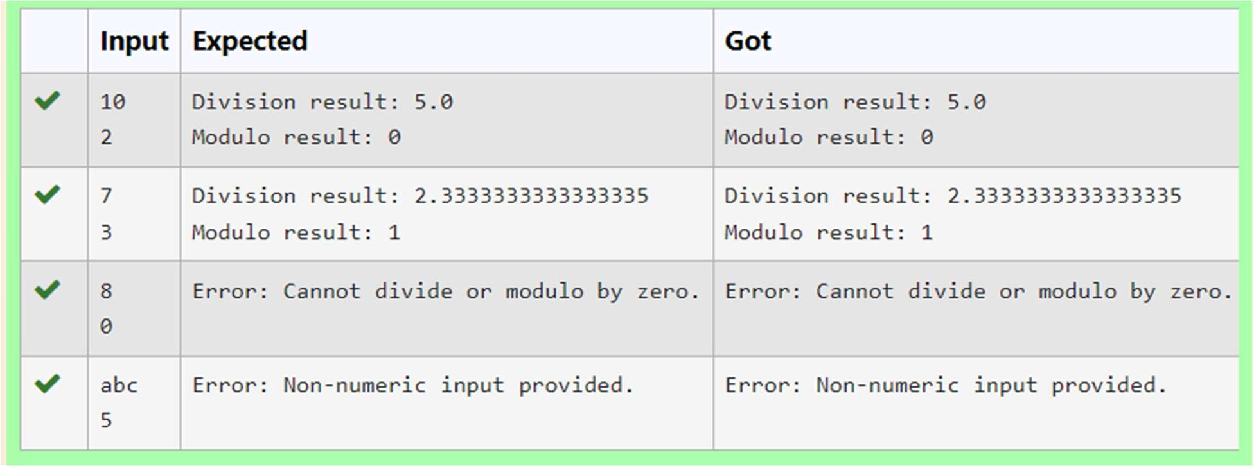

**Department of Computer ScienceandEngineering**|**Rajalakshmi EngineeringCollege**

185

**Ex.No. : 11.3 Date:02.06.24**



**RegisterNo.:230701381 NameVIJAYATHA.L**

# EXCEPTIONHANDLING

WriteaPythonprogramthataskstheuserfortheirageandprintsamessagebasedon the age. Ensure that the program handles cases where the input is not a valid integer.

**InputFormat:**Asingle lineinputrepresentingtheuser's age.

**Output Format:** Print a message based on the age or anerror if the input is invalid.

**Forexample:**



|  |  |
| --- | --- |
| **Input** | **Result** |
| twenty | Error:Pleaseenteravalid age. |
| 25 | Youare25yearsold. |
| -1 | Error:Pleaseenteravalid age. |

**Program:**

try:

a=input()

ifint(a)>=0:

print("Youare",a,"yearsold.") else:

print("Error:Pleaseenteravalidage.") except:

print("Error:Pleaseenteravalidage.")

.

**Department of Computer ScienceandEngineering**|**Rajalakshmi EngineeringCollege**

186

.



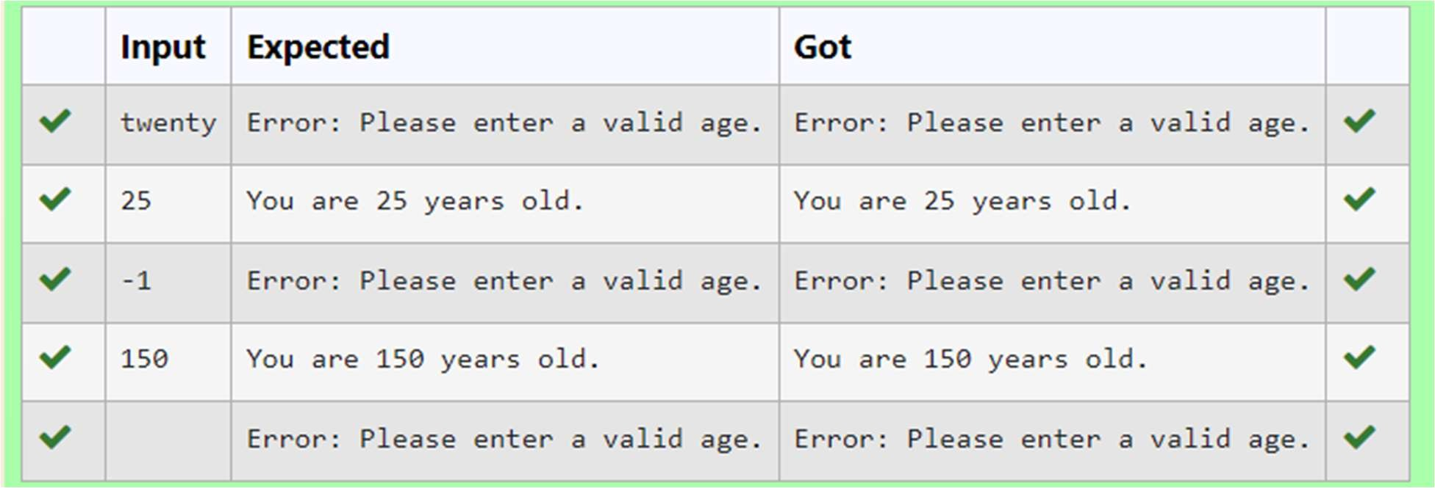

**Department of Computer ScienceandEngineering**|**Rajalakshmi EngineeringCollege**

187



**Ex.No. : 11.4 Date:02.06.24**

**RegisterNo.:230701381 Name:VIJAYATHA.L**

# EXCEPTIONHANDLING

DevelopaPythonprogramthatsafelycalculatesthesquarerootofanumber provided by the user. Handle exceptions for negative inputs and non-numeric inputs.

InputFormat:

Userinputsanumber. Output Format:

Printthesquarerootofthenumberoranerrormessageifanexceptionoccurs.

**Forexample:**

|  |  |
| --- | --- |
| **Input** | **Result** |
| 16 | Thesquarerootof16.0is4.00 |
| -4 | Error:Cannotcalculatethesquarerootofanegativenumber. |
| rec | Error:couldnotconvertstringtofloat |

**Program:**

importmath try:

n=input() n=float(n) if n < 0:

print("Error:Cannotcalculatethesquarerootofanegativenumber.") else:

r=math.sqrt(n)

.

**Department of Computer ScienceandEngineering**|**Rajalakshmi EngineeringCollege**

188

print("Thesquarerootof{}is{:.2f}".format(n,r))

.



exceptValueError:

print("Error:couldnotconvertstringtofloat")

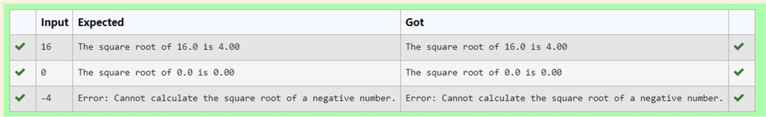

**Department of Computer ScienceandEngineering**|**Rajalakshmi EngineeringCollege**

189



**Ex.No. : 11.5 Date:02.06.24**

**RegisterNo.:230701381 Name:VIJAYATHA.L**

# EXCEPTIONHANDLING

Develop a Python program that safely performs division between two numbers provided by the user. Handle exceptions like division by zero and non-numeric inputs.

**InputFormat:**Twolinesofinput,eachcontaininganumber.

**Output Format:** Print the result of the division or an error message if an exception occurs.

**Forexample:**



|  |  |
| --- | --- |
| **Input** | **Result** |
| 10  2 | 5.0 |
| 10  0 | Error:Cannotdivideormodulobyzero. |
| ten 5 | Error:Non-numericinputprovided. |

**Program:**

try:

a=input() b=input() c=float(a)/float(b)

exceptZeroDivisionError:

.

**Department of Computer ScienceandEngineering**|**Rajalakshmi EngineeringCollege**

190

print("Error:Cannotdivideormodulobyzero.") except:

.



print("Error:Non-numericinputprovided.") else:

print(c)

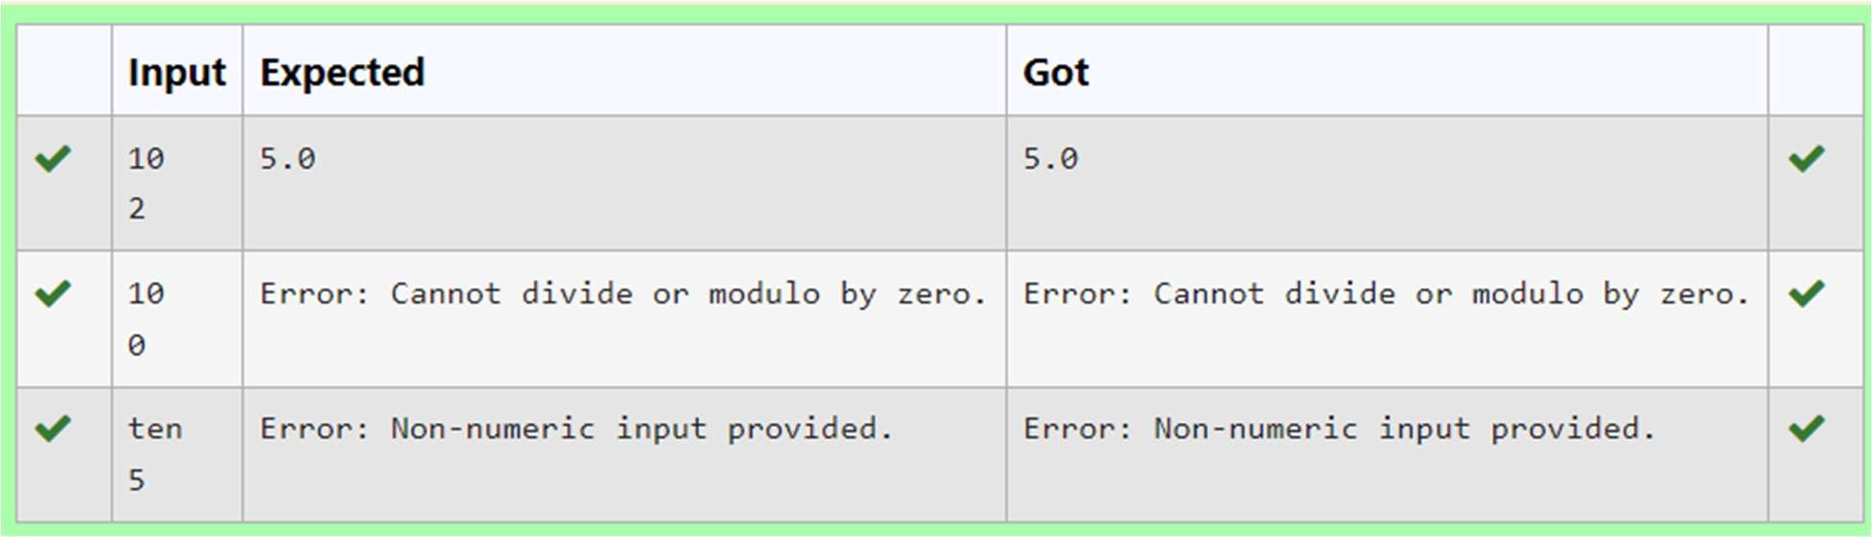

**Department of Computer ScienceandEngineering**|**Rajalakshmi EngineeringCollege**

191